How to Edit Profile Photos and Upload Them into webCV

- Right click on the image you wish to edit and open it with the Photoshop application.

- Transform the image from Landscape mode to Portrait mode.

  - Click on the Crop icon in the Photoshop toolbox.

  - Make sure that you are using the Ratio option after clicking on the Crop icon. If not, click the drop-down menu and select it.

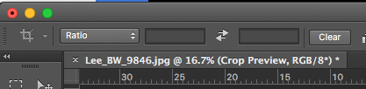

  - The image should now have a box around it. Grab the sides of this box until the said box takes a portrait shape. Once you have the shape you want, click the Crop icon tool once more. This will crop the image for you. See below for a before and after.
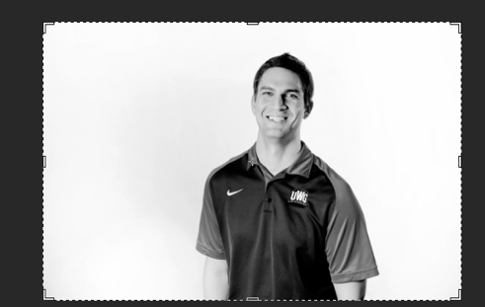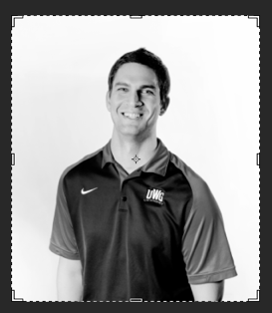

- Shrink down the resolution of the image.
  - Click Image and then Image Size.

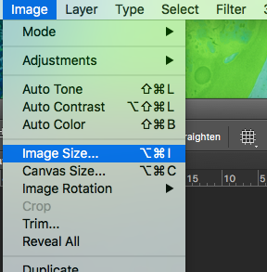
  - You should now be looking at the Image Size popup window. This is where we will change the pixel size of the image.
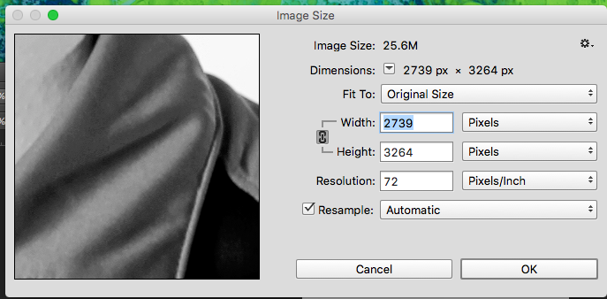
  - Make sure the Chain Icon to the right of the Width and Height text is selected. This guarantees that the image stays in proportion when altering its size.

  - If you can try getting the size to around 400 x 450 pixels, that would be best. But if you can’t due to constraining the proportion, that is perfectly fine. My profile image is 400 x 462 pixels.

- Now save the image.
  - Save the image by going to File, Save.
  - Make sure the image is saved as a .jpg.
  - Use the following file name convention. firstname-lastname-faculty/staff-year Example: lee-augsburger-staff-2017
- Compress the image to cut down on load times and data usage.
  - Go to the TinyPNG website, https://tinypng.com/. If you see a panda on the site, you’re most likely in the right place.
  - Drag your newly edited photo into the Drop Zone of this site and let the website do the rest. When done down load the image to somewhere on your computer and extract the file.
- Upload the photo to webCV.
  - Go to webcv, https://apps.westga.edu/webcv/ and log in with your UWG credentials.
  - Go to myInfo, then to myBio. You should be on a page that looks like the one below. This is how to navigate to your profile from the home page.
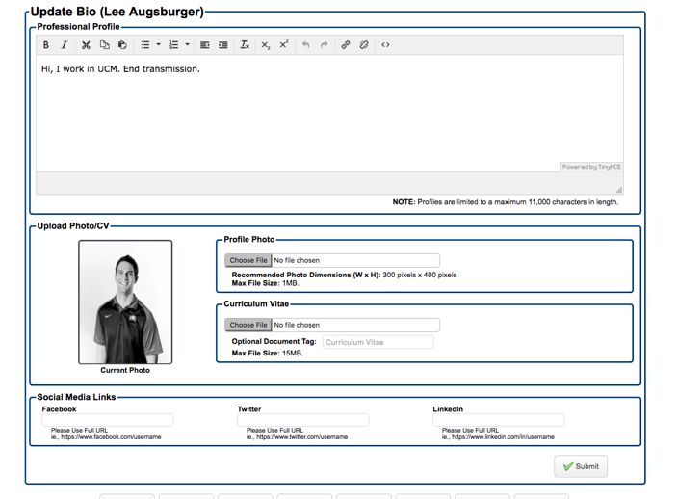
  - If you wish to view all faculty and or staff in a particular department, go to Admin, then all Faculty and Staff from the homepage.
  - At the bottom of this page, you should see a Department drop-down box, select the department you are looking for and click list people to the right. You should now see a list of people from that department. Simply click Bio next to their name at this point.

  - Click on Choose File under Profile Photo and pick the image you wish to upload. Don’t listen to the recommended image dimensions, they lie. Your image may look slightly squished, but that is fine. It will look fine in the OU Campus. If you follow these dimensions, your image will look stretched in OU Campus. See the below example.
Webcv OU Campus

  - Click submit in the bottom right corner of the page.

- Go to the profile page on the UWG site to see how their profile picture looks. If it looks good, you are done. If it looks a bit off (stretched or squished), repeat all the steps in this guide until you are satisfied.

